Whereas, ...; and,

Whereas, ...; and,

Whereas, ...; and,

Whereas, ...; and,

Whereas, ...

Therefore let it be resolved, that....

Therefore let it further be resolved, that....

Respectfully Submitted,
Author #1 Name, Author #1 Title (i.e. School Name NCC/NRHH-CC, RBD Title)
Author #2 Name, Author #2 Title (i.e. School Name NCC/NRHH-CC, RBD Title)

--------------------------Delete these lines and everything in between these lines before submitting legislation----------------------------
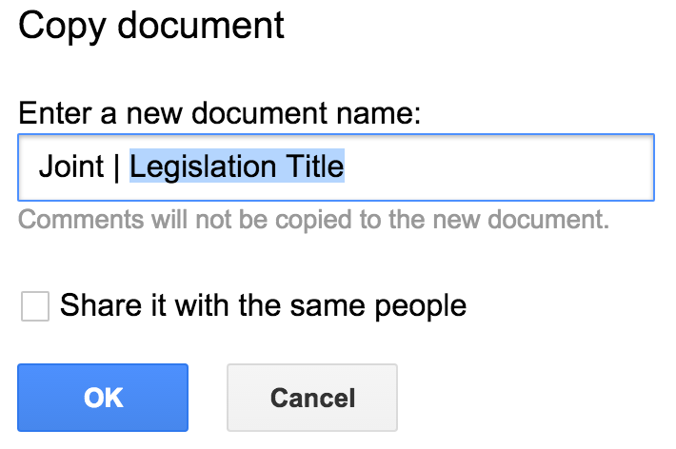
Template Instructions
- To make this process easier, you should sign in with your gmail account or create one so that you can save your changes to your drive.
- Make a Copy of this document Go to “File > Make a copy…”
- Update the “(Legislation Title)” in the header of the document.
- Change the filename to reflect the image to the right.
  - Be sure to leave in “Joint | “.
- You “do not” need to share it with the same people (see image to the right).
- When you’re ready to submit your legislation, simply share the link with gl_director@nacurh.org.
--------------------------Delete these lines and everything in between these lines before submitting legislation----------------------------

